Simply Impressive Thesis Title Line 1

Simply Impressive Thesis Title Line 2

Text Type*: Times New Roman*

Text Size: *26*



Width: 1.72

Height: 1.72

By

Student Name1

Student Name2

Just student names (NO ROLL NO)

Text Type: *Time New Roman*

*Text Size: 18*

Just student names (NO ROLL NO)

Text Type: *Time New Roman*

*Text Size: 18*

Recent Month and Year

Department of Information Technology

University of Haripur

September, 2016

Title of Thesis

Text Type*: Times New Roman*

Text Size: *26*



Text Type*: Times New Roman*

Text Size: *18*

By

Student Name1, Student Name1

2387, 2388

Supervised by

Dr. X

Department of Information Technology

University of Haripur

September, 2016

Title of Thesis



Text Type*: Times New Roman*

Text Size: *26*

Text Type*: Times New Roman*

Text Size: *18*

By

Student Name1, Student Name2

Text Type*: Times New Roman*

Text Size: *14*

A Dissertation Submitted in Partial Fulfilment for the Degree of

BACHELORS/ MASTER OF SCIENCE

IN

COMPUTER SCIENCE

Text Type*: Times New Roman*

Text Size: *18*

Department of Information Technology

University of Haripur

September, 2016

Title of Thesis

Text Type*: Times New Roman*

Text Size: *26*

Text Type*: Times New Roman*

Text Size: *18*

By

Student Name1, Student Name2

Text Type*: Times New Roman*

Text Size: *12*

CERTIFICATE

A THESIS SUBMITTED IN THE PARTIAL FULFILMENT OF THE

REQUIRMENTS FOR THE DEGREE OF BACHELORS

IN COMPUTER SCIENCE

We accept this dissertation as conforming to the required standards

Supervisor Name

Project Supervisor

Examiner Name

External Examiner

Syed Shabih Ul Hasan (For BSCS)/Adeel Ahmed (For BSSE/MCS)

Final Year Project

Coordinator

Dr. Mukhtaj Khan

Chairman

Text Type*: Times New Roman*

Text Size: *18*

Department of Information Technology

University of Haripur

September, 2016

*Line1*

Spaces: 3 lines with font size 25

*Line2*

*Line3*

Text Type*: Times New Roman*

Text Size: *26*

Declaration

*Line1*

Spaces: 2 lines with font size 25

*Line2*

I hereby declare that this dissertation is neither as a whole or part thereof has been copied out from any source. If any part of this thesis is proved to be copied or found to be a report of some other, we shall bear the consequences. No portion of this work presented in the thesis has been submitted in support of any application from any other degree of qualification or any other university or any other institute of learning.

I further declare that this research and all the associated documents with this, reports and all records are submitted as a partial requirement of the degree of Bachelor/ Masters in Computer Science. We understand and transfer copyrights for these materials to University of Haripur and we will not sale this research and documents for getting any financial gains. It is further declared that I developed this and also this thesis is entirely on the basis of our personal efforts made under the sincere guidance of the project supervisor Dr. Y. Saeed, Department of Information Technology, University of Haripur, Haripur.

Date: 15th Jan, 2016 *Student1 Name Student2 Name*

*Signature*  *Signature*

*Line1*

Spaces: 3 lines with font size 25

*Line2*

*Line3*

Text Type*: Times New Roman*

Text Size: *26*

Plagiarism Certificate

*Line1*

Spaces: 2 lines with font size 25

*Line2*

This thesis has been checked for Plagiarism. Turnitin report endorsed by Supervisor is attached at the end of thesis.

Date: 15th Jan, 2016

Student Name(s)

Student Signature

Supervisor Signature

Text Type: Times New Roman

Text Size: 16

Dedicated to

*any one the student intends to dedicate*

*Line1*

Spaces: 3 lines with font size 25

*Line2*

*Line3*

Text Type*: Times New Roman*

Text Size: *26*

Acknowledgements

*Line1*

Spaces: 2 lines with font size 25

*Line2*

Acknowledgement text start here. It should contain acknowledging people who facilitated the student in carrying out the project.

*Line1*

Spaces: 3 lines with font size 25

*Line2*

*Line3*

Text Type*: Times New Roman*

Text Size: *26*

Abstract

*Line1*

Spaces: 2 lines with font size 25

*Line2*

Abstract text start here. It should contain what exactly the student is about to do in thesis.

*Line1*

Spaces: 3 lines with font size 25

*Line2*

*Line3*

Text Type*: Times New Roman*

Text Size: *26*

Table of Contents

*Line1*

Spaces: 2 lines with font size 25

*Line2*

|  |  |  |  |  |  |  |  |  |
| --- | --- | --- | --- | --- | --- | --- | --- | --- |
| Declaration | | | | . . . . . . . . . . . . . . . . . . . . . . . . . . . . . . . . . . . . . . . | | | | i |
| Dedication | | | | . . . . . . . . . . . . . . . . . . . . . . . . . . . . . . . . . . . . . . . | | | | ii |
| Acknowledgements | | | | | | | . . . . . . . . . . . . . . . . . . . . . . . . . . . . . . . . . . . | iii |
| Abstract | | | . . . . . . . . . . . . . . . . . . . . . . . . . . . . . . . . . . . . . . . . . | | | | | iv |
| List of Figures | | | | | | . . . . . . . . . . . . . . . . . . . . . . . . . . . . . . . . . . . . . . | | v |
| List of Tables | | | | | | . . . . . . . . . . . . . . . . . . . . . . . . . . . . . . . . . . . . . . | | vi |
| **Chapter 1** | | | | | | **Introduction**. . . . . . . . . . . . . . . . . . . . . . . . . . . . . . | | 1 |
| 1.1 | | This is the heading of the chapter . . . . . . . . . . . . . . . . . . . . . . . . . . | | | | | | 1 |
|  | | 1.1.1 | | | This is the sub-heading . . . . . . . . . . . . . . . . . . .   . . . . . . . . | | | 1 |
| **Chapter 2** | | | | | | **Related Work** . . . . . . . . . . . . . . . . . . . . . . . . . . . . . . | | 11 |
| **Chapter 3** | | | | | | **Proposed System** . . . . . . . . . . . . . . . . . . . . . . . . . . . . | | 21 |
| 3.1 | Requirement Analysis . . . . . . . . . . . . . . . . . . . . . . . . . . . . . . . . | | | | | | | 21 |
| 3.2 | Design . . . . . . . . . . . . . . . . . . . . . . . . . . . . . . . . . . . . . . . | | | | | | | 25 |
| 3.3 | Methodology . . . . . . . . . . . . . . . . . . . . . . . . . . . . . . . . . . . . | | | | | | | 30 |
| **Chapter 4** | | | | | | **Evaluation and Results** . . . . . . . . . . . . . . . . . . . . . . . . | | 36 |
| 4.1 | Implementation . . . . . . . . . . . . . . . . . . . . . . . . . . . . . . . . . . . | | | | | | | 36 |
| 4.2 | Testing . . . . . . . . . . . . . . . . . . . . . . . . . . . . . . . . . . . . . . . | | | | | | | 45 |
| **Chapter 5** | | | | | | **Conclusion and Future Work**. . . . . . . . . . . . . . . . . . . . . | | 50 |
| 5.1 Conclusion . . . . . . . . . . . . . . . . . . . . . . . . . . . . . . . . . . . . . | | | | | | | | 50 |
| 5.2 Future Work . . . . . . . . . . . . . . . . . . . . . . . . . . . . . . . . . . . . | | | | | | | | 51 |
| **Appendix** | | | | | | . . . . . . . . . . . . . . . . . . . . . . . . . . . . . . . . . . . . . . | | 53 |
| **References** | | | | | | . . . . . . . . . . . . . . . . . . . . . . . . . . . . . . . . . . . . . . | | 54 |

*Line1*

*Line2*

*Line3*

List of Figures

*Line1*

*Line2*

|  |  |  |
| --- | --- | --- |
| **Figure** | **Description** | **Page** |
| 1 | Figure 1 description shall be written here | 1 |
| 2 | Figure 2 description shall be written here | 2 |

*Line1*

*Line2*

*Line3*

List of Tables

*Line1*

*Line2*

|  |  |  |
| --- | --- | --- |
| **Table** | **Description** | **Page** |
| 1 | Table 1 description shall be written here | 1 |
| 2 | Table 2 description shall be written here | 2 |

*Line1*

*Line2*

*Line3*

Chapter 1

*Line1*

Introduction

*Line1*

*Line2*

Text of Chapter 1 starts here. Note that the title Chapter 1 Introduction shall be non-bold and in small letter as mentioned. Sample text is C showed significant information in-crease, where it got enriched by millions of web pages. Explains the reading and understanding of scientific concepts.

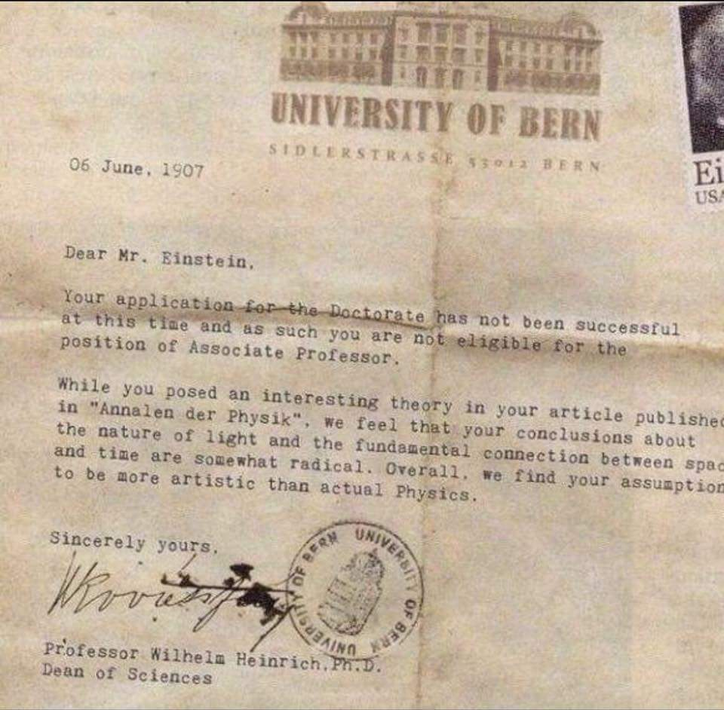

**Figure 1:** Figure description shall be written down the figure (non-italic)

* 1. **Heading**

Font size for the heading is 14. Use small letters and bold.

**1.1.1 Sub-Heading**

Font size for the sub-heading is 12. Use small letters and bold.

**Table 1:** Table description shall be on top of the table (non-italic)

|  |  |  |  |  |
| --- | --- | --- | --- | --- |
|  | Col1 | Col2 | Col2 | Col3 |
|  |  |  |  |  |
|  |  |  |  |  |
|  | 1 | 6 | 87837 | 787 |
|  | 2 | 7 | 78 | 5415 |
|  | 3 | 545 | 778 | 7507 |
|  | 4 | 545 | 18744 | 7560 |
|  | 5 | 88 | 788 | 6344 |
|  |  |  |  |  |

*Line1*

*Line2*

*Line3*

Chapter 2

*Line1*

Existing Systems

*Line1*

*Line2*

Text of chapter 2 starts here ..

2

*Line1*

*Line2*

*Line3*

Chapter 3

*Line1*

Proposed System

*Line1*

*Line2*

Chapter 3 text goes here ..

*Line1*

*Line2*

*Line3*

Chapter 4

*Line1*

Evaluation and Results

*Line1*

*Line2*

Evaluation and Results gained goes in Chapter 4 and starts here ..

*Line1*

*Line2*

*Line3*

Chapter 5

*Line1*

Conclusion and Future Work

*Line1*

*Line2*

**5.1 Conclusion**

Conclusion shall be written here ..

**5.2 Future Work**

Future work starts here ..

*Line1*

*Line2*

*Line3*

References

*Line1*

*Line2*

References starts here and shall be written in IEEE format. Use proper format for the References as mentioned in Microsoft Word or Latex. The student is free to use any of these two editors and their References formats (IEEE).

# References

|  |  |
| --- | --- |
| 1. | "Package Index," Developer, [Online]. Available: https://www.developer.android.com/reference/packages.html. [Accessed 28 June 2017]. |
| 2. | "Android," Wikipedia, [Online]. Available: http://www.wikipedia.com/child app. [Accessed 12 June 2017]. |